# Setting up Application Environment Install IBM Cloud CLI

|  |  |
| --- | --- |
| Team ID | B2-2E4M |
| Project Name | Skill/Job Recommender Application |

**Step 1.** Navigate to cloud.ibm.com

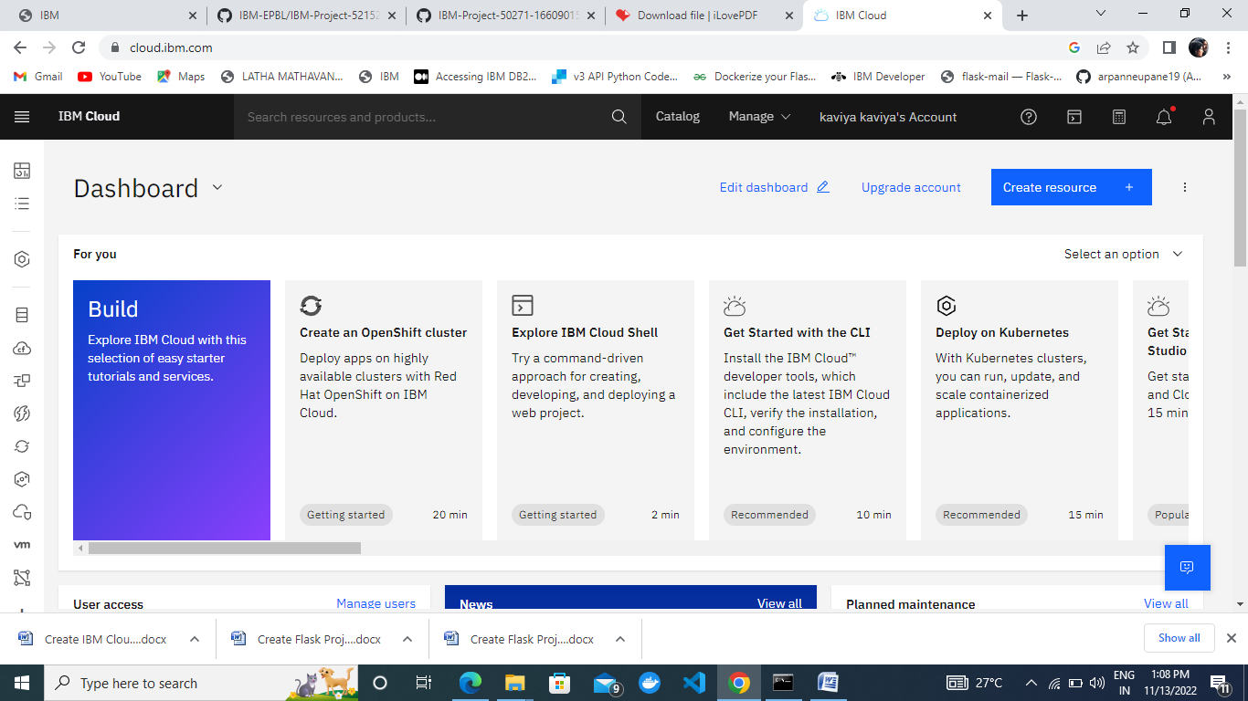

**Step 2**. Search on Container Registry and give get started and follow the steps to install IBM Cloud CLI

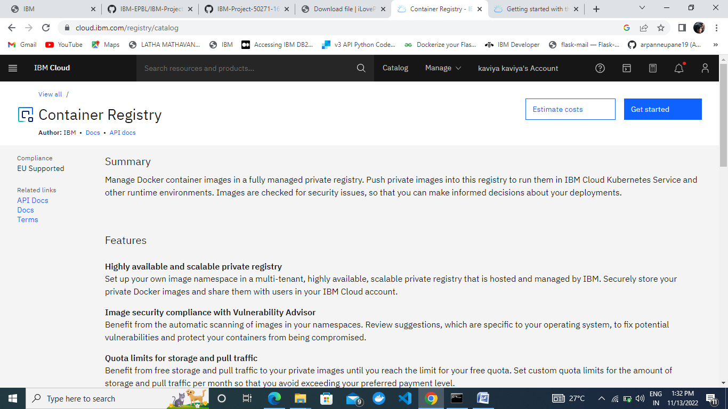

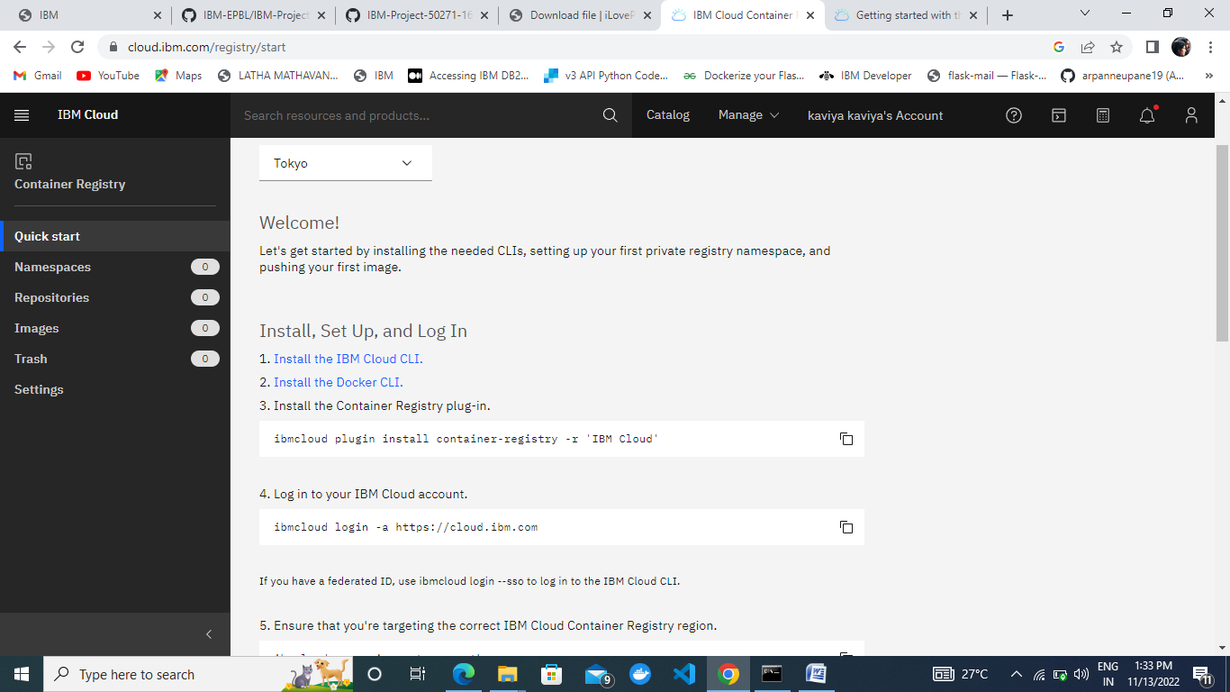

**Step 3**.Download windows 64 bit installer

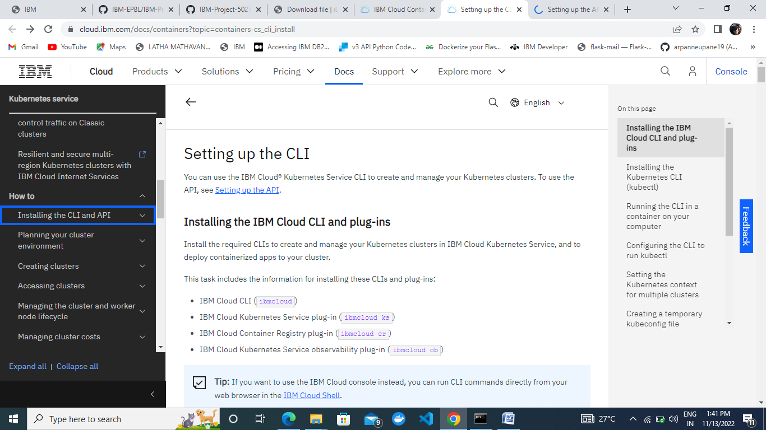

**Step 4.** Open the downloaded .exe file and run it to install IBM Cloud CLI

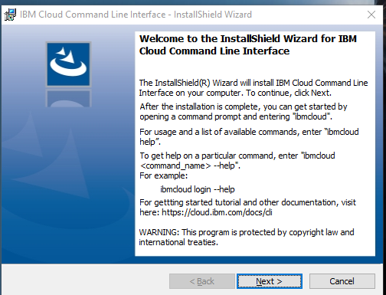

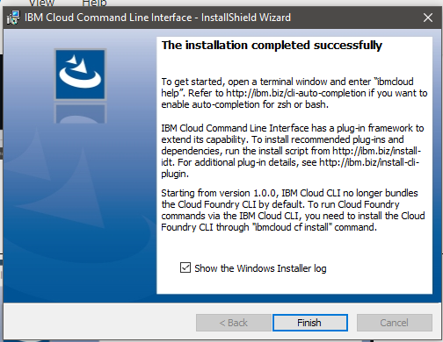

# OUTPUT:

IBM Cloud CLI is installed successfully